CS-3083 Project 5 Report
Bradley Titagwan
Task 1: Hidden Markov Model

Introduction and Task Overview
In this task, I applied a Hidden Markov Model (HMM) to a cybersecurity intrusion tracking problem. In the scenario, an attacker moved through a network of connected machines while each machine contained an intrusion detection alarm. I could not directly observe the attacker’s true location, so I treated the attacker’s position as a hidden state. Instead, I only observed whether each machine’s alarm triggered at every time step. Because alarms could trigger correctly or incorrectly, the evidence was noisy and uncertain.
This made the problem ideal for a Hidden Markov Model. An HMM is a probabilistic model used when the true state of a system is hidden, but indirect observations are available. In this project, the machines represented the hidden states, attacker movement between machines represented state transitions, and the alarm signals represented observations.
The project required three separate inference tasks. First, I reconstructed the most likely full attacker path using the Viterbi algorithm. Second, I estimated the attacker’s current location using filtering. Third, I predicted the attacker’s likely future movement for several future steps.
Method of Implementation
I organized the program around helper functions and three main inference algorithms. I stored the network topology as a dictionary in which each machine contained the set of directly connected neighboring machines. This was efficient because the transition model required checking only legal moves. I assumed that the attacker moved uniformly to one connected neighbor at each time step.
The observation model used two probabilities. If the attacker was on a machine, that machine’s alarm triggered with probability p1, which was the true positive rate. If the attacker was not on a machine, that machine’s alarm triggered with probability p2, which was the false positive rate. Since every machine produced an alarm reading at each step, one observation consisted of a dictionary of 1s and 0s for all machines.

I also created helper functions for the initial state distribution, transition probability calculations, emission probability calculations, normalization of probability distributions, and path accuracy scoring. These functions made the three algorithms modular and easier to verify.
Viterbi Algorithm Overview
I implemented the Viterbi algorithm as a dynamic programming method to determine the single most likely hidden state sequence that explained all observations. Instead of checking every possible path directly, which would have been computationally expensive, the algorithm stored only the best partial path to each state at every time step.
For each machine at time t, I checked all possible previous machines at time t-1, combined the previous score with the transition probability, and selected the best predecessor. After processing all observations, I used back pointers to reconstruct the most likely attacker path. I used log probabilities to prevent numerical underflow. Without logs, multiplying many small probabilities across twenty or more time steps could become extremely close to zero.
Filtering Algorithm Overview
I implemented the filtering algorithm to estimate the current state after processing all observations. Rather than producing a single path, filtering produced a full probability distribution over all machines. At each time step, I projected the previous belief distribution forward using transition probabilities. Then I updated those predictions using the alarm evidence. Finally, I normalized the probabilities, so they summed to one. The machine with the highest final probability became my best estimate of the attacker’s location.
Prediction Algorithm Overview
I implemented the prediction algorithm to estimate future hidden states after the final observation. Starting from the filtering distribution, I repeatedly applied only the transition probabilities because future evidence was unknown. This allowed me to estimate likely attacker positions one to five steps into the future.

Experimental Results and Comparisons
Default Test Run
The default test used five machines, a connection density of 0.2, a true positive rate of 0.95, a false positive rate of 0.05, and twenty observations.
The Viterbi algorithm achieved an accuracy of 1.00, meaning every inferred attacker location matched the ground truth path.
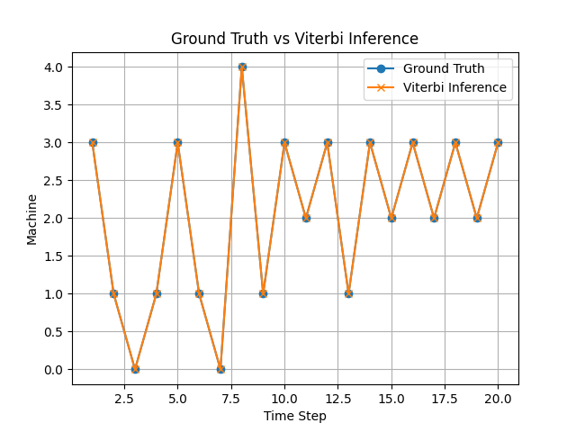
The complete overlap of the two plotted lines confirmed that the algorithm correctly recovered the full hidden path.
I performed a second run to verify repeatability. The inferred path again closely matched the true path, which showed that performance remained strong across random trials.
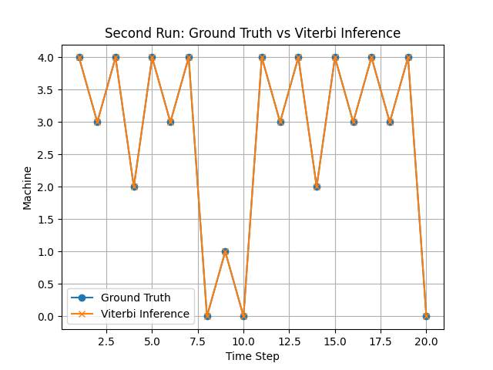
Filtering Test
The final filtering distribution assigned almost all probability mass to machine 3. This meant that the evidence strongly indicated that machine 3 was the attacker’s current location. This demonstrated the usefulness of filtering in real security environments. Even if I did not need the entire historical path, I could still estimate the attacker’s present position.
Prediction Test
The future predictions alternated mainly between machines 0 and 3. This indicated that the current belief state and transition structure strongly favored movement between those nodes.
As future distance increased, uncertainty naturally grew because no new evidence was added.
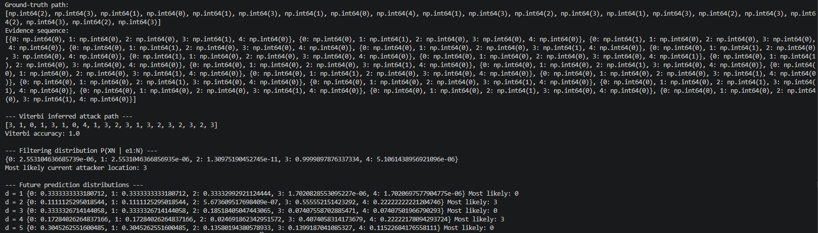

Comparison 1: Number of Machines
I increased the number of machines to test how the state space size affected inference.
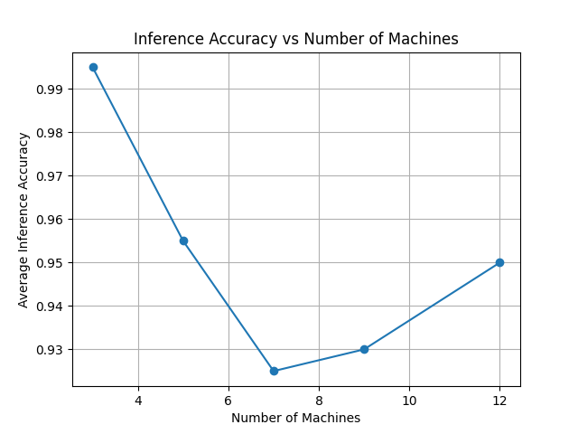
Accuracy was highest with only three machines and generally decreased as more machines were added. This occurred because a larger number of hidden states created more possible attacker paths, increasing ambiguity. Although some fluctuation occurred due to random graph topology, the overall trend showed that larger systems were harder to infer perfectly.
Comparison 2: Alarm Sensitivity
I varied the true positive rate to test alarm quality.
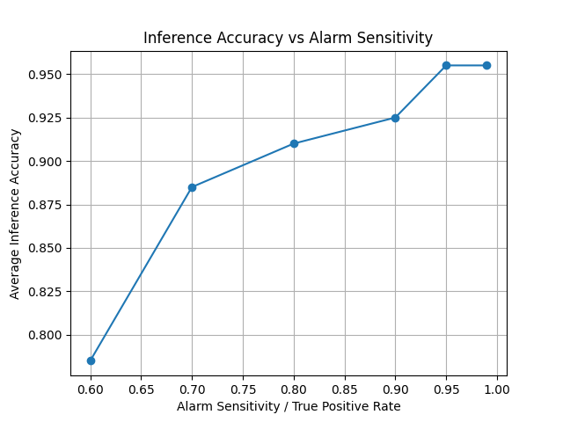
When sensitivity was low, many real attacks failed to trigger alarms, so the evidence was weak. As sensitivity increased, inference accuracy rose sharply. This confirmed that accurate sensors were extremely valuable in hidden-state tracking.
Comparison 3: Alarm Noise
I varied the false positive rate to test noisy IDS behavior.
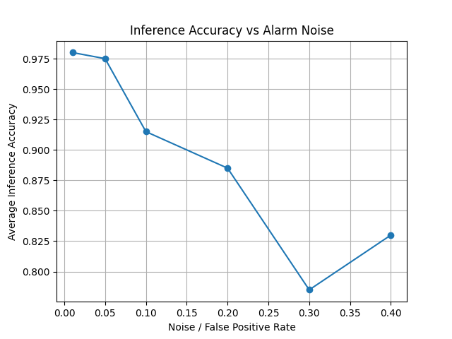
As noise increased, inference quality declined. False positives made safe machines appear suspicious, which confused the model and spread probability mass across multiple states. This result matched real cybersecurity challenges where excessive false alerts reduced analyst confidence.
Comparison 4: Sequence Length
I varied observation length to test longer attack histories.
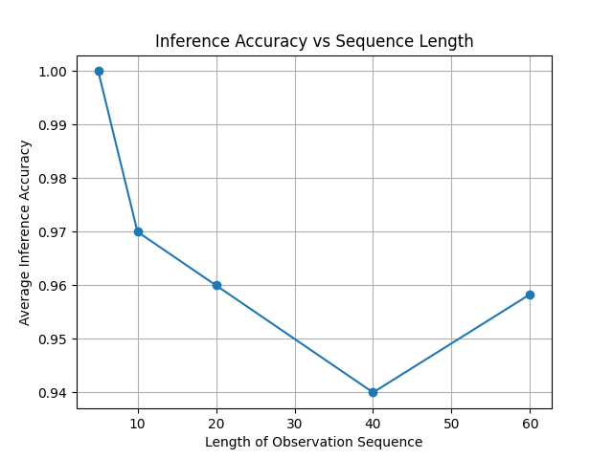
Short sequences were easiest to reconstruct perfectly. Longer sequences slightly reduced accuracy because more hidden states had to be inferred, and isolated mistakes could affect later path consistency. However, performance remained high overall.
Topology Comparison
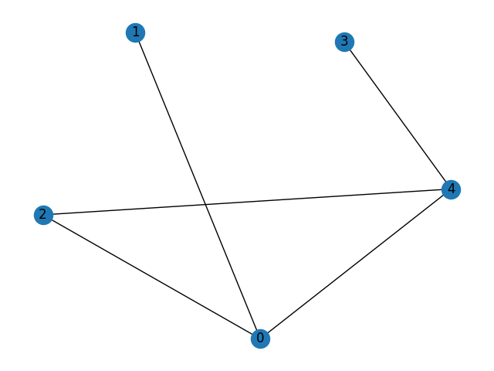
I also generated different network topologies.
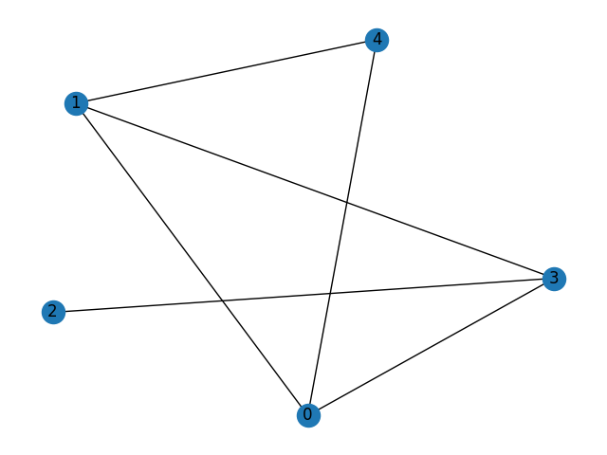
Sparse networks with fewer movement choices tended to be easier, while denser networks created more uncertainty because attackers had more legal transitions.
Discussion
This task demonstrated that HMMs were highly effective when states were hidden but noisy evidence existed. The Viterbi algorithm worked best when I needed the full historical path. Filtering worked best when only the current state mattered. Prediction was useful for forecasting likely future movement.
The main strengths of the HMM were robustness, probabilistic reasoning, and strong accuracy. Limitations included simplified attacker behavior, assumed known probabilities, and increased difficulty in larger or noisier systems.
Conclusion
The Hidden Markov Model successfully solved the intrusion tracking problem. It reconstructed attacker paths with high accuracy, estimated current attacker location with strong confidence, and predicted future movement trends. Better alarms improved results, while higher noise and larger networks made inference harder. This task showed how HMMs could be valuable tools for intrusion detection and attacker movement analysis.

Task 2: Markov Decision Process
Introduction and Task Overview
In this task, I used a Markov Decision Process (MDP) to model cloud server scaling decisions. A cloud provider had to continuously decide whether to reduce servers, maintain current capacity, increase capacity, or maximize capacity. These decisions affected future workload states and long-term profitability.
The four workload states were Low, Medium, High, and Overloaded. The four available actions were down, stay, up, and max.
An MDP is a mathematical model for sequential decision-making under uncertainty. It was appropriate when an agent repeatedly chose actions, received rewards, and moved probabilistically to future states.
My objective was to implement two solution methods, which are Value Iteration and Policy Iteration. Both methods were required to determine the optimal policy and analyze convergence behavior.
Method of Implementation
I stored the transition probabilities as nested dictionaries in the form: P[action][state][next_state]
This allowed efficient lookup of probabilities. I stored utility values in dictionaries indexed by state, and I stored policies as dictionaries mapping states to actions. I implemented a reusable Q-function: Q(s,a) = expected reward of taking action a in state s
This function combined immediate reward with discounted future utility. I then created a one-step look-ahead function that used Q-values to determine the best action for a state and the best utility value for a state. Using the same helper logic for both algorithms ensured consistency.
Value Iteration Overview
I implemented Value Iteration by repeatedly applying the Bellman optimality equation. Starting from zero utilities, I updated each state by selecting the action with the highest expected long-term reward. I continued this process until changes became smaller than a threshold controlled by epsilon. Once utilities converged, I extracted the policy by choosing the action with the maximum Q-value.

Policy Iteration Overview
I implemented Policy Iteration using two repeated phases. First, policy evaluation computed utilities assuming the current policy was fixed. I solved this exactly using linear algebra. Second, policy improvement checked whether any better action existed in each state. If so, I updated the policy. I repeated the process until the policy no longer changed.

Experimental Results and Comparisons
Default Results
With gamma = 0.90 and epsilon = 0.10, both algorithms produced the same optimal policy:
Low → down, Medium → down, High → stay, Overloaded → up
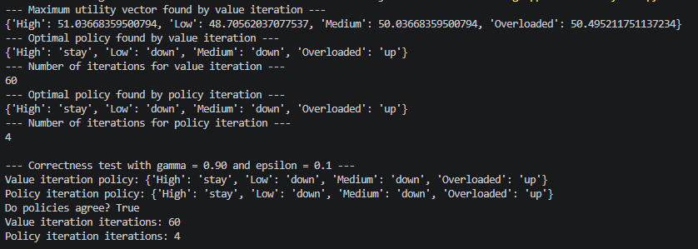

When demand was Low or Medium, reducing servers saved unnecessary cost. At High demand, staying at the current level balanced revenue and cost. When Overloaded, increasing servers was optimal.

Correctness Comparison
Both Value Iteration and Policy Iteration converged to the exact same policy. Since the two methods solved the problem differently, this strongly confirmed implementation correctness.
Policy Iteration required only four iterations, while Value Iteration required sixty. This demonstrated the efficiency advantage of Policy Iteration.

Comparison 1: Effect of Gamma
Gamma controlled how much future rewards mattered.
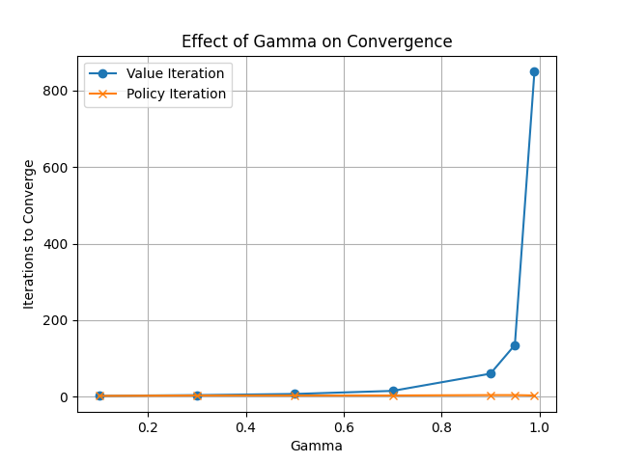
When gamma was small, convergence was fast because decisions focused mostly on immediate reward. As gamma increased toward 1, Value Iteration required dramatically more iterations because utilities became heavily dependent on future utilities.
Policy Iteration remained near constant and converged quickly across all tested gamma values. This showed that Policy Iteration was much better suited for long-term planning scenarios.

Comparison 2: Effect of Epsilon
Epsilon controlled the stopping tolerance for Value Iteration.
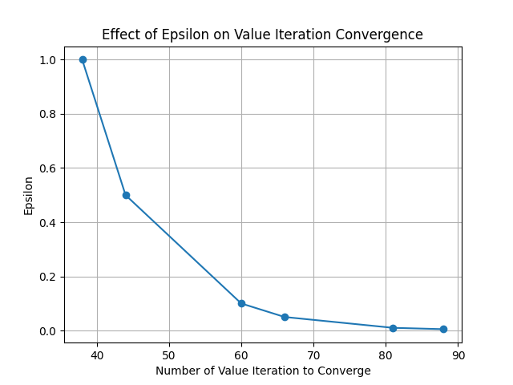
Large epsilon values allowed earlier stopping with fewer iterations. Small epsilon values required stricter precision and, therefore, more iterations.
This matched theoretical expectations exactly.

Special Test: Gamma ≥ 0.99
I tested very high gamma values to examine near-infinite horizon behavior.
At gamma = 0.99, Value Iteration required hundreds of iterations. At gamma = 0.995 it required thousands. At gamma = 0.999 it required over ten thousand iterations.
Policy Iteration still converged in only three rounds. Both methods still agreed on the final policy.

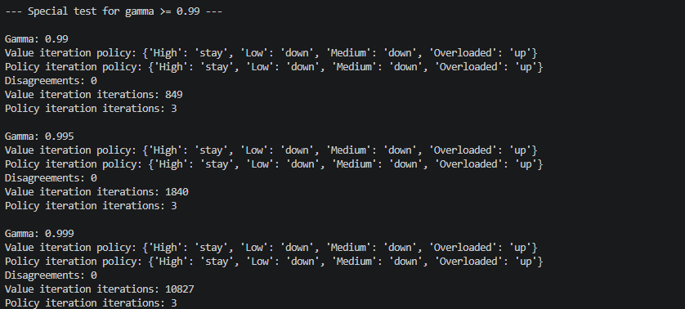
This showed that extremely high gamma values might not change the optimal decision, but they severely increased computational cost for Value Iteration.

Discussion
This task demonstrated two important MDP solution methods. Value Iteration was simple and reliable, but became slow when long-term rewards dominated. Policy Iteration was more complex because it solved linear systems, but it converged much faster in many cases.
The task also showed why cloud scaling naturally fit the MDP framework. Every server decision changed future workloads, future revenue, and future costs.

Conclusion
Both algorithms successfully solved the cloud resource allocation problem and produced the same optimal policy. Policy Iteration converged much faster than Value Iteration, especially at large gamma values. Smaller epsilon values increased convergence time, while high gamma values greatly slowed Value Iteration. This task demonstrated how Markov Decision Processes could be powerful tools for automated decision-making and long-term optimization.

Lessons Learned
From Task 1, I learned how Hidden Markov Models can be used to reason under uncertainty when the true state of a system cannot be directly observed. I saw how noisy evidence, such as imperfect alarm signals, could still be used to accurately reconstruct an attacker’s path, estimate a current location, and predict future movement. I also learned the practical differences between the Viterbi algorithm, filtering, and prediction. Viterbi focused on the most likely full sequence, filtering focused on the present state, and prediction focused on future states. This task also showed me how model accuracy depends heavily on sensor quality, false positive rates, and state space size.
From Task 2, I learned how Markov Decision Processes can be used to make optimal sequential decisions when actions affect future outcomes. I developed a stronger understanding of utilities, rewards, policies, discount factors, and convergence. I saw how Value Iteration and Policy Iteration both solve the same optimization problem but use different approaches. Value Iteration repeatedly improved utility estimates, while Policy Iteration alternated between evaluating and improving policies. I also learned that high gamma values can significantly slow convergence, especially for Value Iteration.
Overall, both tasks taught me how probability and optimization methods can be applied to real-world problems. Task 1 focused on inference under uncertainty, while Task 2 focused on decision-making under uncertainty. Together, they showed how intelligent systems can both understand hidden situations and choose the best actions in dynamic environments.

